Weekly Report

Tengteng Tao

9/18/2018-9/25/2018

Goal:

Setting bounds for parameters. Plot the value of R^2 and the value of cost function.

Plot:

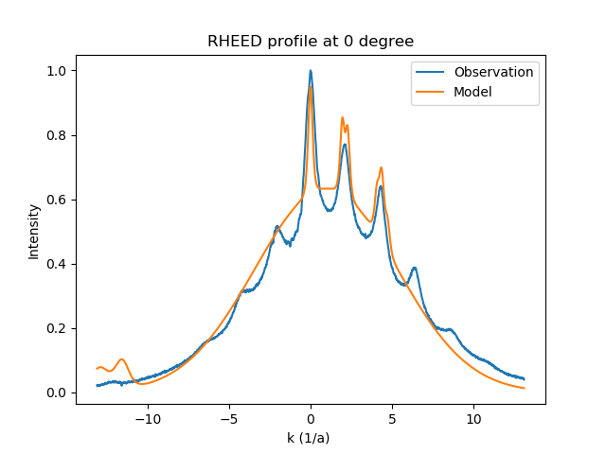

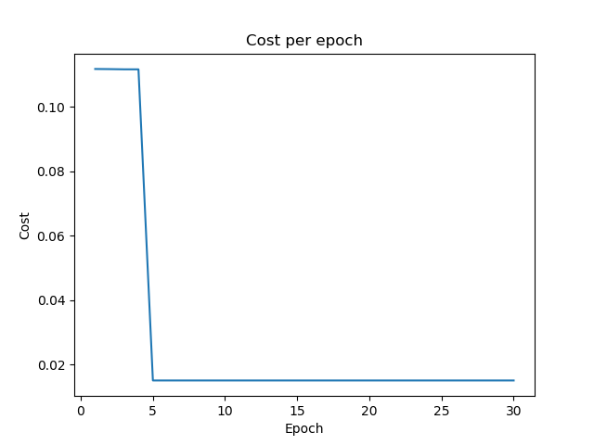

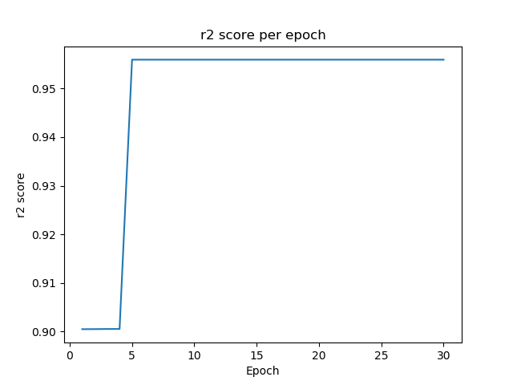

Fitting parameters :

|  |  |  |  |  |  |
| --- | --- | --- | --- | --- | --- |
| $$ξ$$**($Å$)** | A  arbitrary unit | B  arbitrary unit | $$X_{C}$$ $${(Å}^{-1})$$ | $$σ$$**($Å^{-1}$)** | $$φ$$**degree** |
| 3.2935 | $$2.2005∙{10}^{-5}$$ | 0.6325 | -0.9502 | 4.3688 | 14.999 |

|  |  |  |  |  |  |  |  |  |
| --- | --- | --- | --- | --- | --- | --- | --- | --- |
| x1 | x2 | x3 | x4 | x5 | x6 | x7 | x8 | x9 |
| 2.2734 | -11.6116 | -0.13 | $$-5.0158∙{10}^{-3}$$ | 1.9502 | 4.0718 | 4.7272 | 4.3241 | $$4.4062$$ |

$$R^{2}= 0.9559$$

What I am thinking:

After calculating the R^2 number and plotting the cost function, I found that the R^2 number is very close to 1, which means the function should fitted the data very well. However, according to the plot, the accuracy of fitting was not high enough. In order to figure out this problem, I checked Jiazhao's program and PowerPoint. I found that he added a Gaussian function in cost function. Accordingly, I added a Gaussian function in a similar position in my code.

Here is the result:

Plot:

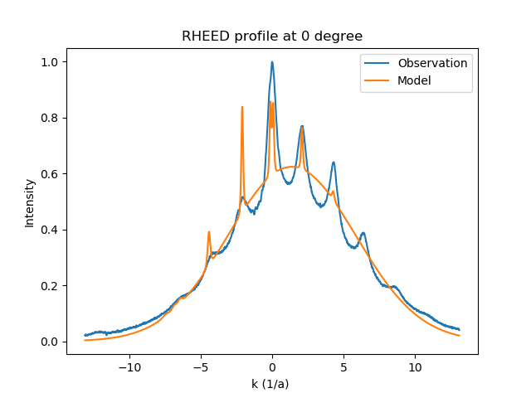

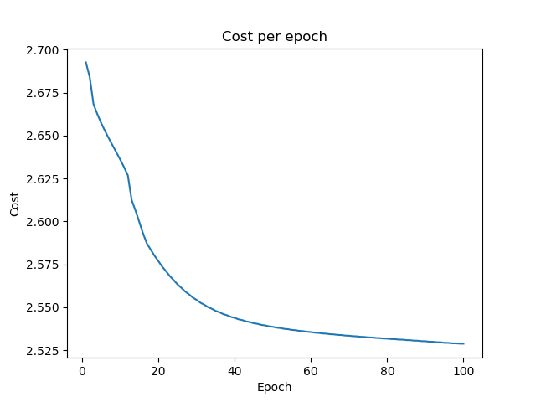

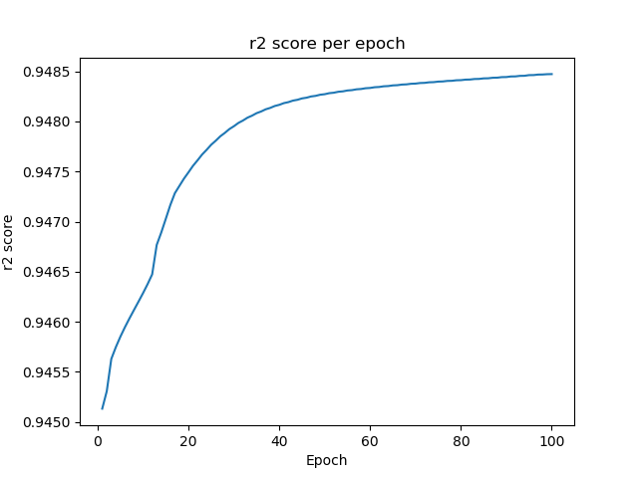

|  |  |  |  |  |  |
| --- | --- | --- | --- | --- | --- |
| $$ξ$$**($Å$)** | A  arbitrary unit | B  arbitrary unit | $$X_{C}$$ $${(Å}^{-1})$$ | $$σ$$**($Å^{-1}$)** | $$φ$$**degree** |
| 7.0407 | $$1.6423∙{10}^{-5}$$ | 0.6240 | 1.3774 | 4.4675 | 14.999 |

|  |  |  |  |  |  |  |  |  |
| --- | --- | --- | --- | --- | --- | --- | --- | --- |
| x1 | x2 | x3 | x4 | x5 | x6 | x7 | x8 | x9 |
| -6.4581 | -4.4257 | -2.0921 | -0.1171 | 2.0891 | 4.2792 | 0.0700 | -6.8651 | -7.4700 |

$$R^{2}= 0.9485$$

Parameters in Gaussian function

|  |  |  |
| --- | --- | --- |
| a | x0 | sigma |
|  | -0.4306 | $$1∙{10}^{-10}$$ |

Conclusion:

According to the plot, both 2 plots have a R^2 value which is very close to one. Although I added the Gaussian function in cost function, the result did not improve a lot. Accordingly, I think the correction of function will need more knowledge about the physical and math meaning of the fit function. I am going to talk with you about the details tomorrow.